**Title**: Perception of social consensus but not moral conviction affects support for universal health care

**Authors**: Sean X. Duan; Victoria A. Shaffer

**Word Count**: 375/375

**Purpose**: The overwhelming majority of modern countries provide some form of Universal Health Care (UHC), except for the United States. Additionally, recent research shows that health-care beliefs are becoming more polarized. We aimed to learn if psychological theories about the formation and adjustment of polarized beliefs applied to the context of American support for UHC. Across two studies, we manipulated perceived levels of social consensus and moral conviction.

**Method**: Two samples of college students (Study 1 N = 505; Study 2 N = 491) rated their level of support for UHC in America on a 0-100 slider bar, both before and after the intervention. The interventions were a social consensus manipulation (Study 1 & 2) and a moral conviction manipulation (Study 2). In Study 1, participants were exposed to survey information that purported to either depict public support for UHC at 83% or 43%; Study 2 also included a moral consensus manipulation that presented either a morally loaded argument (responsibilities, ethics, etc.) or a non-moral argument (economics, pragmatic and practical execution). In Study 1, we hypothesized that social consensus would affect support for UHC. In Study 2, we hypothesized that there would be an interaction between our social consensus and moral conviction manipulations, with decreases in moral conviction associated with an increase in the effectiveness of the social consensus manipulation.

**Results**: In Study 1, the social consensus manipulation had a significant effect on support for UHC, P<.05; Support for UHC increased in the ‘high’ social consensus condition and decreased in the ‘low’ social consensus condition. In Study 2, we replicated the main effect of social consensus affecting support for UHC, P<.05; however, we did not detect significant interaction with moral conviction.

**Conclusions**: Perception of social consensus leads to significant changes in support for UHC in college students. Furthermore, increasing or decreasing the saliency of the moral element does not seem to interact with the effects of social influence, at least in the context of universal health care. Given that public opinion has such a strong influence on support for UHC, clearly advertising to the public that the majority of society is in agreement with UHC may be an effective strategy to promote policy change.

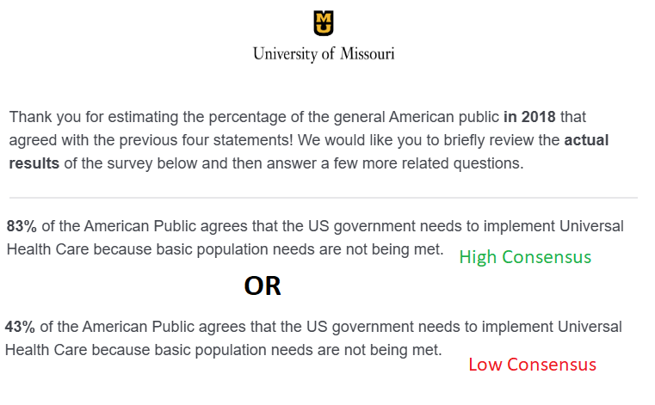

Figure 1. ‘High’ and ‘Low’ social consensus manipulation used for Study 1 & 2